Date : ………………………..  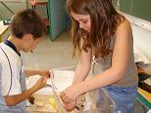 | 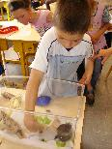 |  | Date :………………………..
LE NETTOYAGE DU VIVARIUM  Ta phrase :  ________________________________________________________________________________________________________________________________________________________  La phrase choisie par la classe :  ____________________________________________________________________________________________________________________________________________________________________________________________________________ |  |  | LE NETTOYAGE DU VIVARIUM  Ta phrase :  ________________________________________________________________________________________________________________________________________________________  La phrase choisie par la classe :  ____________________________________________________________________________________________________________________________________________________________________________________________________________

